inquiry@icvisp.org
+852-30696823
2024 8th International Conference on Vision, Image and Signal Processing (ICVISP 2024)
Dec. 27-29 |Xishuangbanna, China | www.icvisp.org
NOTE: Make sure to submit all required documents: 1. final paper (doc & pdf files), 2. completed registration form, 3. Payment Voucher to inquiry@icvisp.org(Mail Subject: Paper ID + Registration).
- ATTENDEE INFORMATION
*Full Name: | 1-inch-Photo here
*Position√: Prof. Assoc. Prof. Asst. Prof. Dr. Mr. Ms.
*Affiliation & Nation:
*Email:
*Mobile Phone:
*Alternative Liaison (Name & Mobile):
Address& Zip Code (for post use):
Catering (On-site conference on Dec. 28): Lunch Dinner
Special dietary√: Diabetic Vegetarian Halal food Other (please specify: )
Special requirements:

- PAPER INFORMATION
*Paper ID: *Paper Pages: *Extra Page(>5 pages):
*Paper Title:
*Authors:
*Whether to attend the on-site conference? Yes No
*Presentation Type√: Oral Poster
*Participation Certificate√: Softcopy Hardcopy I do not need the certificate
Student ID No. (student only):
IASED Member No. (member only):
* Receipt Issued to:

- PRICE INFORMATION
Onsite Conference
Category |  | Early Birds  (Before Sept. 27, 2024) | Regular  Registration | On-site  Registration  (On Dec. 27, 2024) | Your  Choice
Full Paper Registration | Regular Author | 500USD | 550USD | 600USD
 | Student\  Committee | 450USD | 500USD | 550USD
 | IASED Member | 470USD | 520USD | 570USD
Abstract Registration | Regular Presenter | 400USD | 450USD | 500USD
 | Student\Committee Presenter | 350USD | 400USD | 450USD
 | IASED Member Presenter | 380USD | 430USD | 480USD
Listener\Co-Author |  | 300USD
Others
Additional Page | 70USD
Extra Paper Upload | 300USD
Printed Conference Proceeding | 60USD
Extra Banquet Ticket | 50USD
City Tour\Social Networking Event (Optional) | TBD
Notice
*If the paper exceeds 5 pages, the additional pages will be charged. The recommended general length limit is no less than 4 pages.
*All the presented and registered full papers will be published online.
*Onsite Conference—Full Paper Registration covers: publication fee + meeting sessions on Dec. 28 + 2 coffee breaks, 1 lunch, 1 dinner on Dec. 28 + conference kits.
*Onsite Conference—Abstract Registration covers: meeting sessions on Dec. 28 + 2 coffee breaks, 1 lunch, 1 dinner on Dec. 28 + conference kits. Only do a presentation (without publishing any papers).
*For "No shows", registration fee is nonrefundable.
*Shall the conference be delayed or prevented (directly or indirectly) by the reasons of natural disasters, war, strike(s), epidemic or any other events which could not be controlled, the organizing committee shall be under no liabilities. The organizing committee reserves the right to change the conference date, venue or form of the conference (online or on-site).
*Cancellation policy: Applicant should send the refund/cancellation requests to inquiry@icvisp.org. (The cancellation policy is available on the official website of the ICVISP 2024 on Registration Page: www.icvisp.org).
*Our payment system will not charge any extra fee, but the credit card payment may incur currency exchange charge which is charged by payers' bank, it should be borne by payers.

- PAYMENT INFORMATION
Online Payment linkage
http://meeting.yizhifubj.com/web/main.action?meetingId=351
E-mail: | Confirmation Number:
* VISA /Master cards are recommended payment methods. We will not charge any handling fees, please calculate the amount before you finish the payment.  * Please fill your E-mail address used for payment and Confirmation Number you received after paying.  * As the system will intercept the email address for multiple payments, it is recommended to use different email for each payment  *Please make sure the conference organizer, IASED’s logo is always appear on the page until you click “Pay”. Then you will be directed to payment page. | 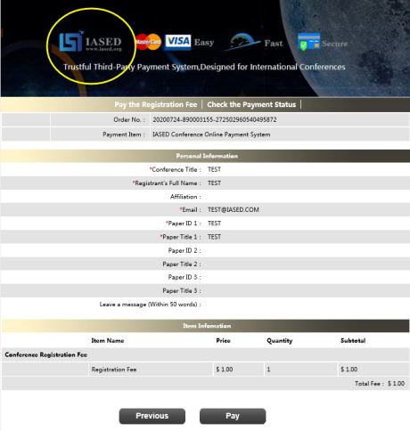
- IASED MEMBER APPLICATION
Join IASED now to quality for member registration rates. Please compile and return the Membership Form along with your CV to membership@iased.org. Your application will be processed in 5 working days.
- OTHER
Finally, we suggest you write down a biographical sketch here, for use of making introductions by Session Chair before your presentation gets started.
20-120 Words (1-3 lines)
Contact us at IASED LinkedIn:
IASED LinkedIn
ICVISP 2024 Organizing Committee
Xishuangbanna, China

