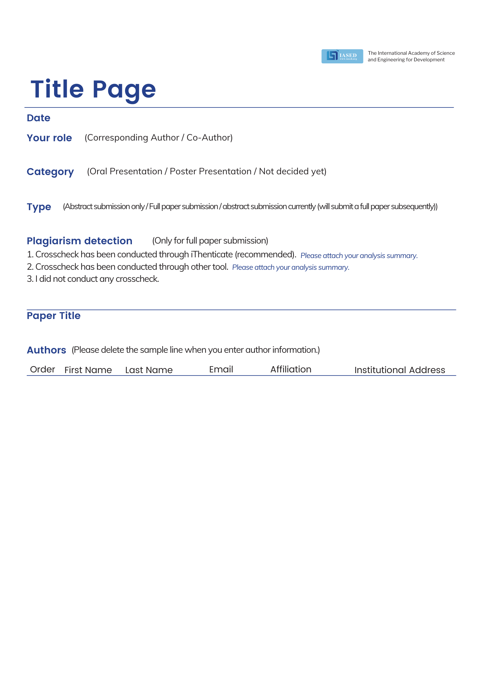

|  |  |  |  |  |  |
| --- | --- | --- | --- | --- | --- |
| 1 |  |  |  |  |  |
| 2 |  |  |  |  |  |
| 3 |  |  |  |  |  |
| 4 |  |  |  |  |  |
| 5 |  |  |  |  |  |

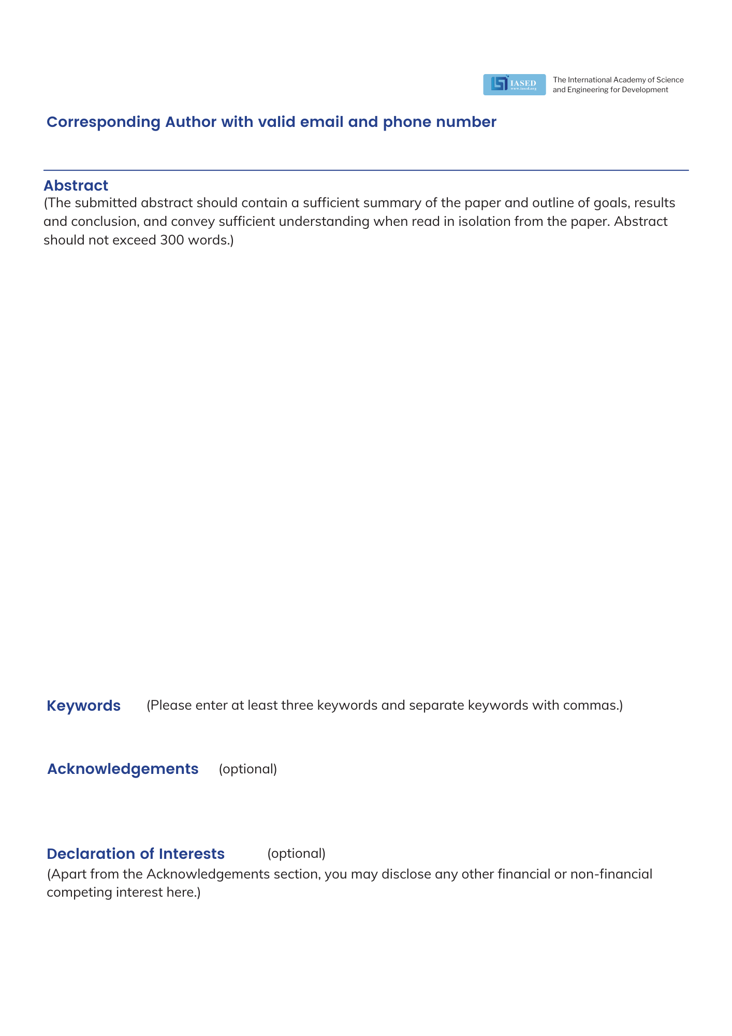

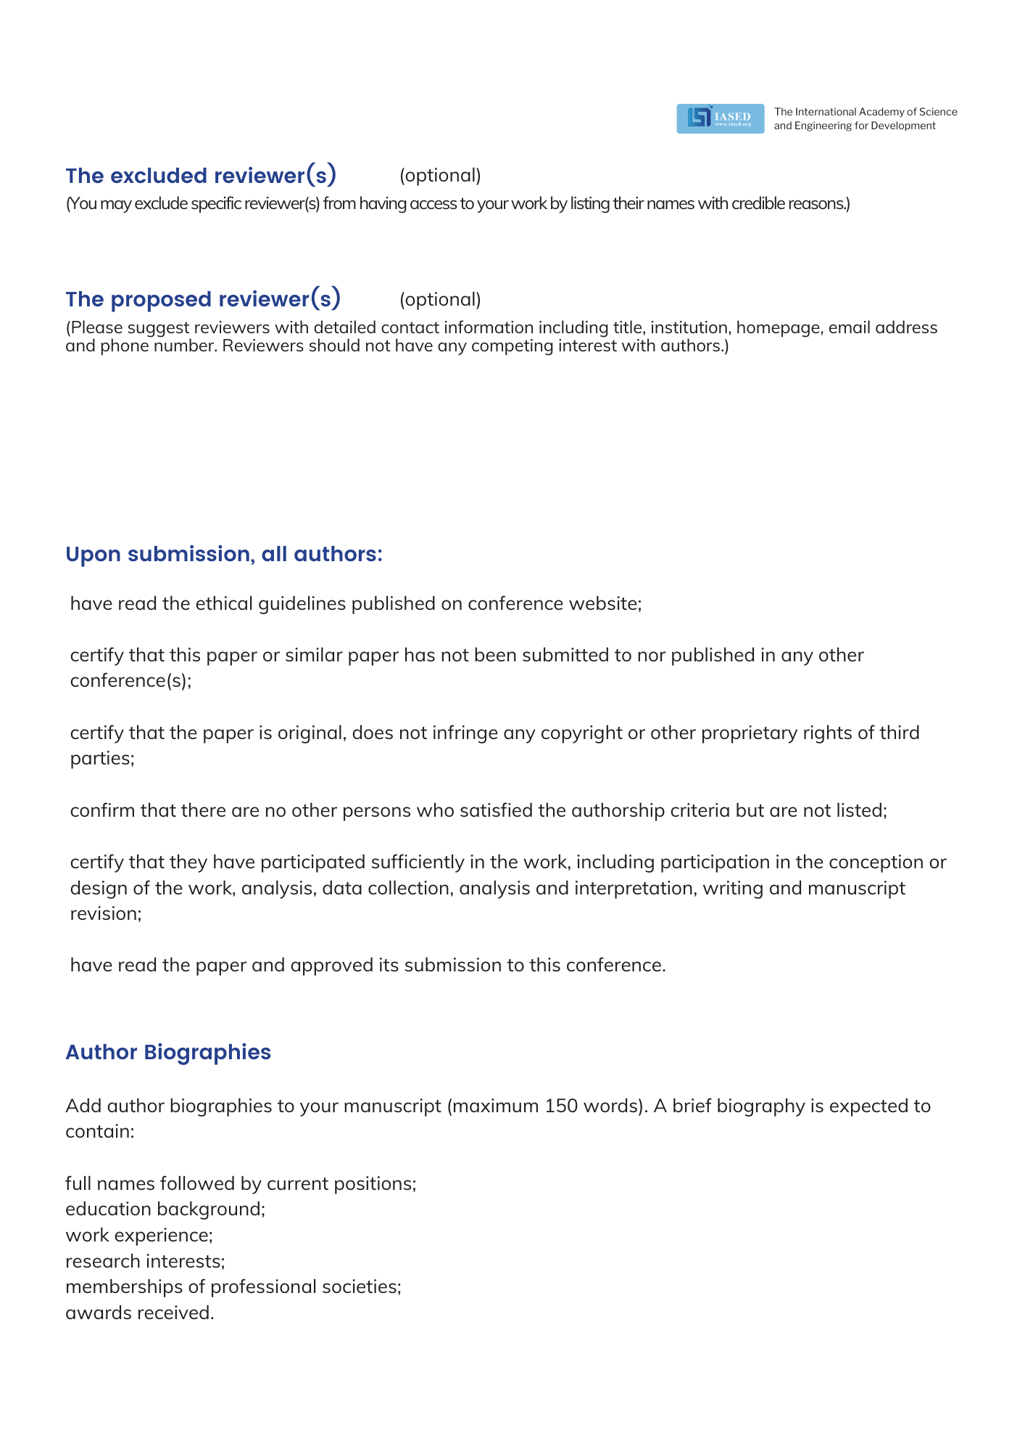



**Conference Secretary: Ms. Sukki H.Chiang**

**Conference Email: inquiry@icvisp.org**

**Tel: +852-30696823(English)**

**Monday-Friday, 9:00am-12:00am and 13:30pm-18:00pm**

|  |  |
| --- | --- |
| **Full Name** | **Short Biography (Maximum 150 words)** |
|  |  |
|  |  |
|  |  |
|  |  |
|  |  |
|  |  |