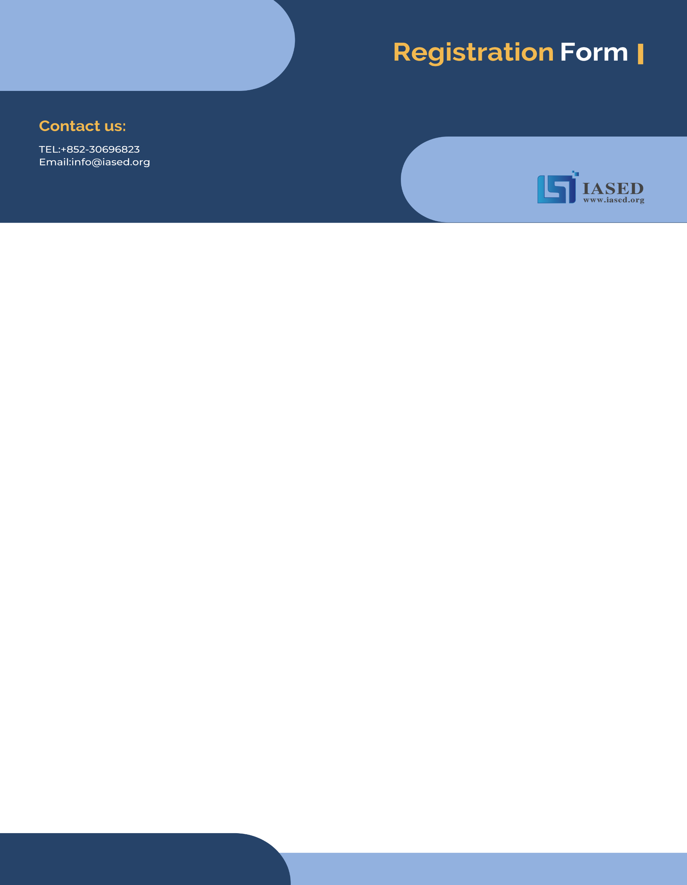
NOTE: Make sure to submit all required documents: 1. final paper (doc & pdf files), 2. completed registration form, 3. Payment Voucher to icvisp@iased.org (Mail Subject: Paper ID + Registration).
2022 International Conference on Vision, Image and Signal Processing (ICVISP 2022)
Dec 9-11 | Kuala Lumpur, Malaysia | www.icvisp.org
- ATTENDEE INFORMATION
*Full Name: | 1-inch-Photo here
*Position√: Prof. Assoc. Prof. Asst. Prof. Dr. Mr. Ms.
*Affiliation & Nation:
*Email:
*Mobile Phone:
*Alternative Liaison (Name & Mobile):
Address& Zip Code (for post use):
Catering (On-site conference on Dec 10): Lunch Dinner
Special dietary√: Diabetic Vegetarian Halal food Other (please specify: )
Special requirements:

- PAPER INFORMATION
*Paper ID: *Paper Pages: *Extra Page(>5 pages):
*Paper Title:
*Authors:
*Will you be present at the on-site conference? Yes No
*Presentation Type√: Oral (15 min) Poster (5 min) Remote Video (15 min) Video (15 min)
*Participation Certificate√: Softcopy Hardcopy I do not need the certificate
Student ID No. (student only):
IASED Member No. (member only):
* Receipt Issued to:

- PRICE INFORMATION
Onsite Conference
Category | Early  (due by Aug 15, 2022) | Regular  (due by Sept 25,2022) | Late  (After Sept 25, 2022) | On-site  (Dec 9-11, 2022) | Your Choice
IASED Member  (Author) | USD 470 | USD 510 | USD 560 | USD 610
Nonmember  (Author) | USD 510 | USD 550 | USD 610 | USD 660
Student  (Author) | USD 430 | USD 460 | USD 490 | USD 540
One Day Program | USD 360 | USD 400 | USD 450 | USD 500
Listener | USD 260 | USD 300 | USD 350 | USD 400
Online Conference
Category | Online Presentation (Until Dec 9, 2022) | Your Choice
IASED Member (Author) | USD 390
Nonmember (Author) | USD 420
Student (Author) | USD 380
One Day Program | USD 300
Listener | USD 230
Others
Extra Item | Cost | Your Choice
Extra Page/Per page | USD 70
Extra Paper Upload | USD 370
Extra Banquet Ticket | USD 50
Notice
*If the paper exceeds 5 pages, the additional pages will be charged. The recommended general length limit is 5-14 pages per paper, and no less than 4 pages.
*All papers will be published online.
*For "No shows", registration fee is nonrefundable.
*Shall the conference is delayed or prevented (directly or indirectly) by the reasons of natural disasters, war, strike(s), epidemic or any other events which could not be controlled, the organizing committee shall be under no liabilities. The organizing committee reserves the right to change the conference date, venue or form of the conference (online or on-site)
*Cancellation policy: Applicant should send the refund/cancellation requests to icvisp@iased.org. (The Cancellation policy are available in the official website of the ICVISP 2022: www.icvisp.org)
*Our payment system will not charge any extra fee, but the credit card payment may incur currency exchange charge which is charged by payers' bank, it should be borne by payers.
*One day program fee covers: Attend meeting sessions on Dec 10. Only do a presentation (without publishing any papers) + coffee breaks, lunch and dinner (onsite conference) + conference kits (onsite conference).
*Full registration fee for conference covers (Onsite Author only): publication fee + meeting sessions on Dec 10+ 2 coffee breaks, 1lunch, 1dinner on Dec 10 + conference kits.

- PAYMENT INFORMATION
Online Payment linkage
http://meeting.yizhifubj.com/web/main.action?meetingId=351
E-mail: | Confirmation Number:
* VISA /Master cards are recommended payment methods. We will not charge any handling fees, please calculate the amount before you finish the payment.  * Please fill your E-mail address used for payment and Confirmation Number you received after paying.  * As the system will intercept the email address for multiple payments, it is recommended to use different email for each payment  *Please make sure the conference organizer, IASED’s logo is always appear on the page until you click “Pay”. Then you will be directed to payment page. | 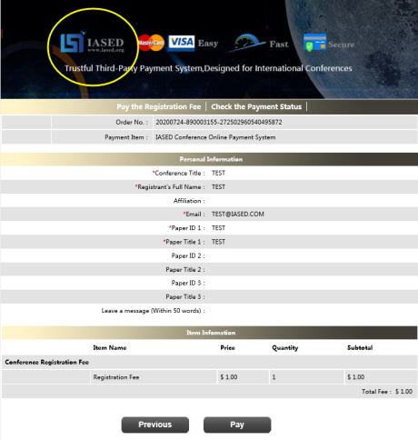
- IASED MEMBER APPLICATION
Join IASED now to quality for member registration rates. Please compile and return the Membership Form along with your CV to membership@iased.org. Your application will be processed in 5 working days.
- OTHER
Finally, we suggest you write down a biographical sketch here, for use of making introductions by Session Chair before your presentation gets started.
20-120 Words(1-3 lines)

Contact us at IASED LinkedIn:
IASED LinkedIn
ICVISP 2022 Organizing Committee
Kuala Lumpur, Malaysia

