ICVISP 2021 Registration Form
2020 5th International Conference on Vision, Image and Signal Processing (ICVISP 2021)
18-20 December, 2021| Kuala Lumpur, Malaysia| www.icvisp.org
NOTE: Please send the required documents: 1. final paper(doc&pdf), 2. filled registration form, 3. Payment Voucher to icvisp@iased.org. (Mail Subject: Paper ID+Registration).
- ATTENDEE INFORMATION

1-inch-Photo here
*Full Name:
*Position√: Prof. □  Assoc. Prof. □  Asst. Prof. □ Dr. □  Mr. □  Ms. □
*Affiliation:
*Nationality:
*Email: *Mobile Phone:
Emergency Contact(Name&Mobile):
Postal Address& Zip Code (for post use):
Catering Service(Dec.19)√: Lunch □ Dinner □
Special dietary√: Diabetic □ Vegetarian Halal food □ Other □ (please specify: )
Special requirements:
- PAPER INFORMATION
*Paper ID: *Paper Pages: *Additional Page:
*Paper Tile:
*Authors:
*Will you attend the conference Yes □ No □
*Presentation Type√: Oral □ Poster □
Student ID No.(student only):
IASED Member No.(member only):
* Receipt Issued to:
- REGISTRATION FEE(by US dollar)
Category | Early  (Until Aug.23) | Regular  (Until Oct. 5) | Late  (After Oct.5) | Onsite  (Dec.18-20) | Online Presentation | Your choice
IASED Member Author | USD 470 | USD 510 | USD 560 | USD 610 | USD 350
Nonmember Author | USD 510 | USD 550 | USD 610 | USD 660 | USD 380
Student Author | USD 430 | USD 460 | USD 490 | USD 540 | USD 320
Presentation Only | USD 360 | USD 400 | USD 450 | USD 500 | USD 250
Listener | USD 260 | USD 300 | USD 350 | USD 400 | USD 200
Social Networking Event | TBD
Academic Visit Optional | TBD

Extra Item | Cost | Your Choice
Extra Page/Per page | USD 70
Extra Paper Upload | USD 370
Extra Banquet Ticket | USD 50
*Notice
*Ordinary length limits is 5-10 pages per paper, If the paper exceeds 6 pages, the additional pages will be charged.
*All the papers will be published on-line.
*For "No shows", registration fee is nonrefundable.
*Cancellation policy: refund/cancellation requests must be submitted before 30 March 2020, and the cancellation will incur US$100 administrative fee. After the date, the request will not be accepted.
*Our payment system will not charge any extra fee, but the credit card payment may incur few exchange commission which is charged by payers' bank, it should be borne by payers.
*One day program fee covers: Attend meeting sessions of Dec. 19 only to do presentation(not publish paper).
*Full registration fee covers :(Author only) publication fee + meeting sessions on Dec. 18-20.

- PAYMENT INFORMATION
URL of of official Online Payment System:
http://meeting.yizhifubj.com.cn/web/main.action?meetingId=351
* The system accepts VISA /Master for payment, please calculate the amount before payment.
Please fill your E-mail address used for payment and Confirmation Number you received after paying.
E-mail: | Confirmation Number:
* As the system will intercept the email address for multiple payments, it is recommended to use different email for each payment
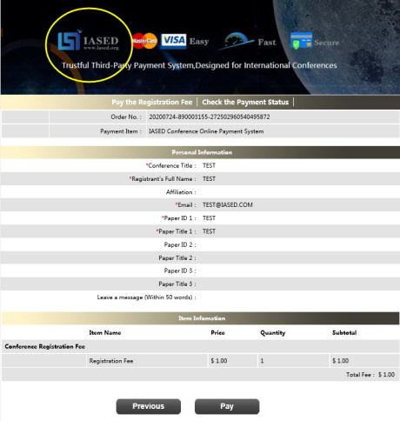
*Please make sure the conference organizer, IASED’s logo is always appear on the page until you click “ Pay”. Then you will be directed to payment page.

- IASED MEMBER APPLICATION
Join IASED now to quality for member registration rates. Please compile and return the Membership Form along with your CV to membership@iased.org. Your application will be processed in 5 working days.
- OTHER
Finally, we suggest you write down a biographical sketch here, for use of making introductions by Session Chair before your presentation gets started. 20-120 Words(1-6.5 lines)

ICVISP 2021 Conference Committee
Kuala Lumpur, Malaysia

